Vulnerability: SQL Injection in Login (Authentication Bypass)

CWE: CWE-89 - Improper Neutralization of Special Elements used in an SQL Command
OWASP: A03:2021 - Injection
CVSS: 9.8 (Critical)
Location: routes/login.ts
Component: Backend API - Login endpoint (POST /rest/user/login)

Description
The login endpoint constructs its SQL query by directly interpolating user-supplied input (req.body.email and the hashed req.body.password) into the query string using JavaScript template literals. Because the input is not parameterized, an attacker can inject arbitrary SQL syntax to manipulate the query's logic and bypass authentication entirely.

Vulnerable code:
models.sequelize.query(`SELECT * FROM Users WHERE email = '${req.body.email || ''}' AND password = '${security.hash(req.body.password || '')}' AND deletedAt IS NULL`, { model: UserModel, plain: true })

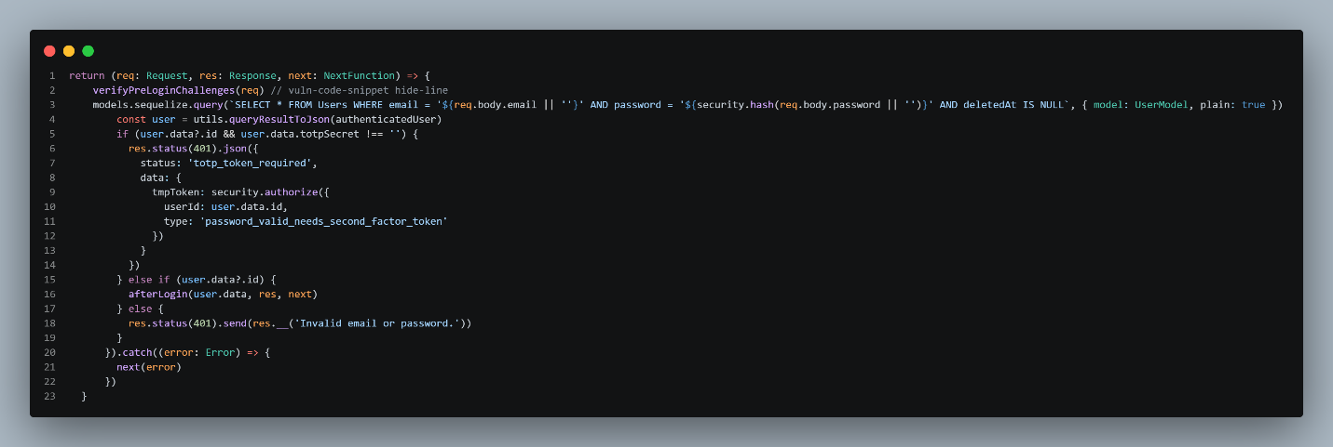

Exploit payload: ' OR TRUE --
admin' OR 1=1--
- Navigate to http://localhost:3000/#/login
- Enter ' OR TRUE-- or admin' OR 1=1-- in the email field.
- Enter any value in the password field.
- Submit the login form.

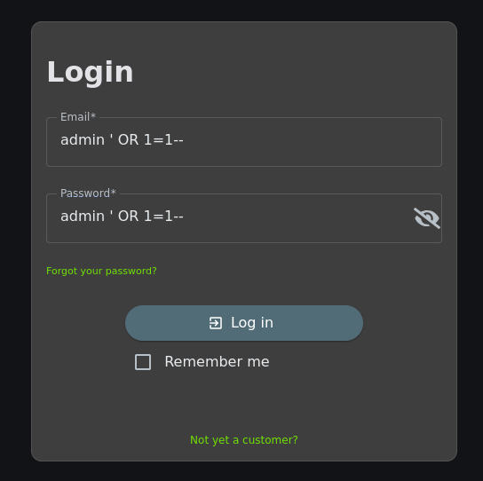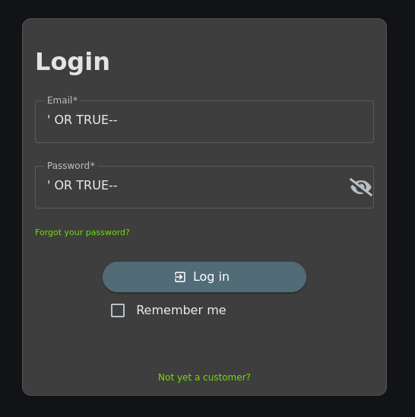

Resulting query executed by the database:
SELECT * FROM Users WHERE email = '' OR TRUE--' AND password = '<hash>' AND deletedAt IS NULL

The Vulnerability:
' OR TRUE --
The application builds the SQL query by directly concatenating user input. The payload ' OR TRUE-- manipulates the query logic,
Part of payload | Effect on the query
' | Closes the email string literal early
OR TRUE | Makes the entire WHERE clause always evaluate to true
-- | Comments on the rest of the query, including the password check
The database ends up returning the first user to the table (the admin) and lets the attacker in without checking a password.

admin' OR 1=1--
This payload targets the admin account specifically: it breaks out with ', adds OR 1=1 always true, then -- comments out the password check.
The database returns the first matching row, the administrator user. The application then issues a valid JWT for that user, granting the attacker full admin access without ever knowing a password.

Evidence - Before Fix
- Login form with ' OR TRU-- or admin' OR 1=1-- entered in the email field and any value in the password field.
- Successful authentication as the administrator account - admin@juice-sh.op, confirming the bypass worked.

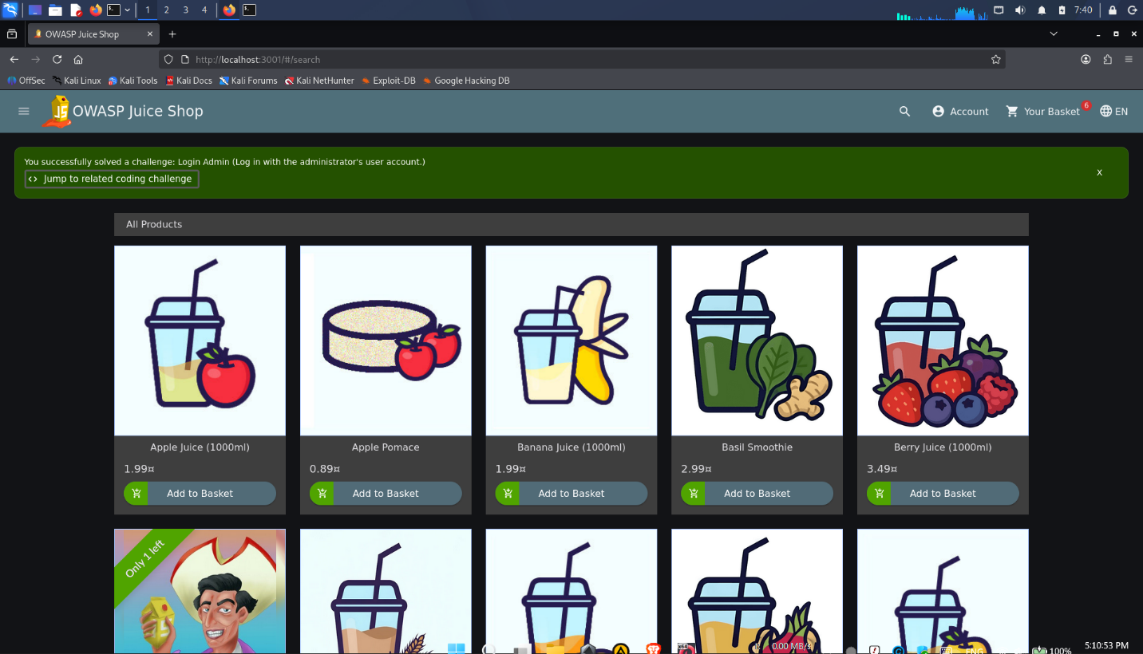

SAST Detection - Before Fix
Tool: Semgrep
Rule: sequelize-template-literal-injection
Run against the unmodified routes/login.ts, Semgrep flags the interpolated query. Capture the finding count and the specific rule ID and line number flagged.

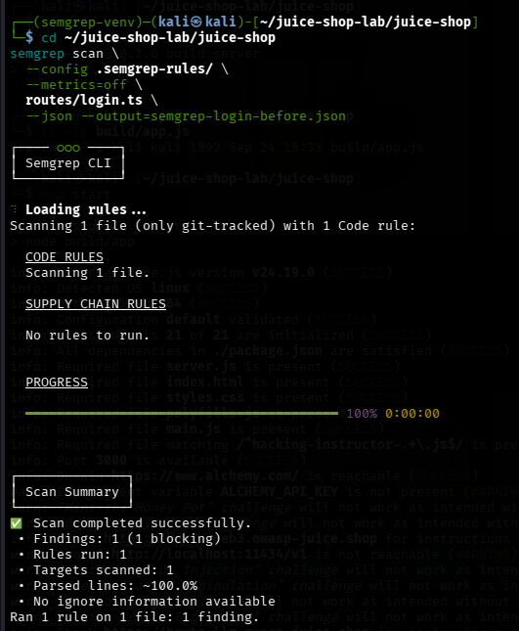
Secure Coding Fix
The correct remediation is to use parameterized queries. In Sequelize, this is achieved by replacing interpolated values with (?) placeholders and passing the values via the replacements array. The database driver then binds each value as data, not SQL syntax.

models.sequelize.query( 'SELECT * FROM Users WHERE email = ? AND password = ? AND deletedAt IS NULL', {replacements: [req.body.email || '', security.hash(req.body.password || '')], model: UserModel, plain: true})

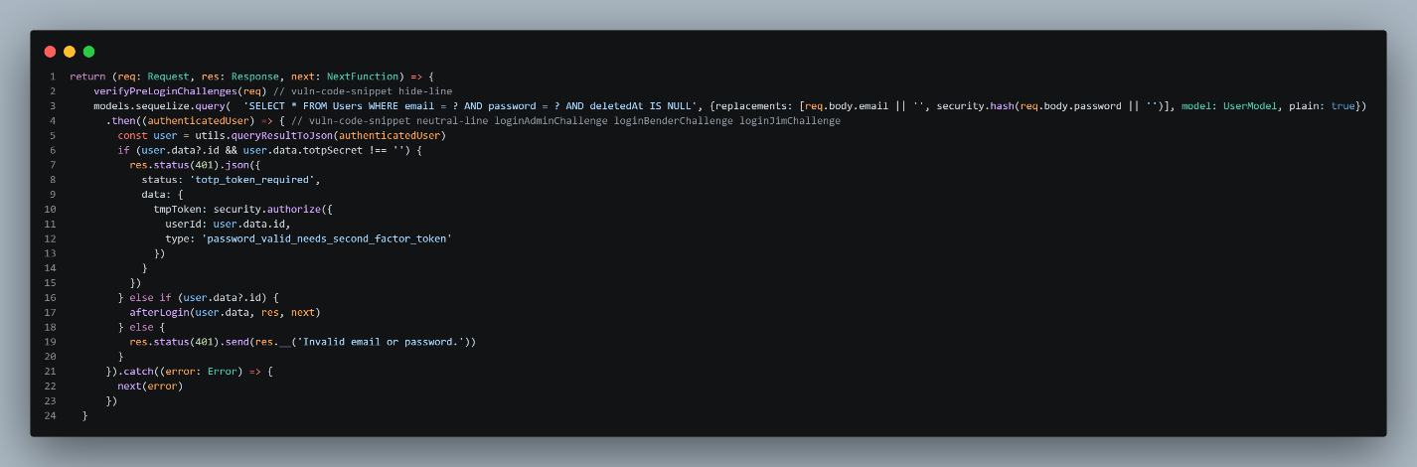

Why this works: With parameterization, the payload ' OR TRUE-- is sent to the database as a literal string value for the email column. The database looks for a user whose email is literally ' OR TRUE-- which does not exist. No user is returned, and authentication fails.

Evidence - After Fix

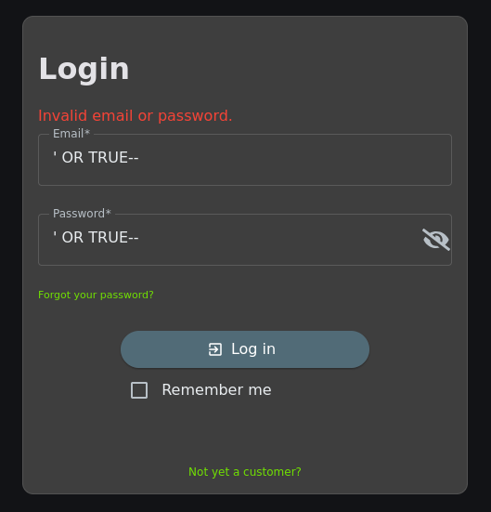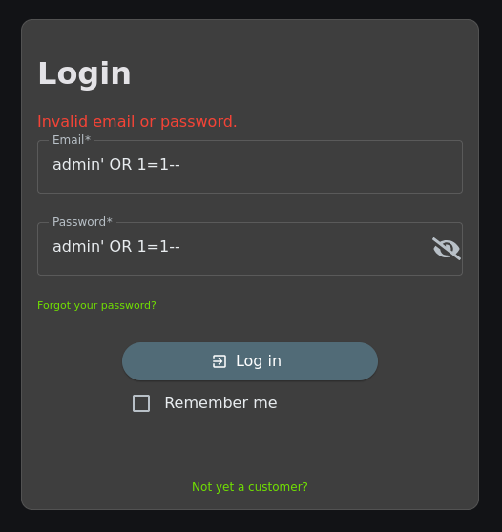

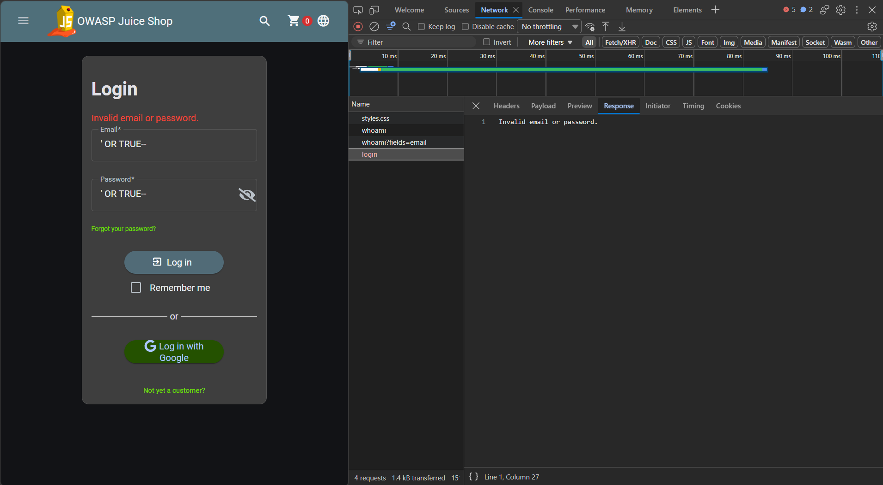

SAST Detection - After Fix
Re-running the same scan on the patched login.ts shows the SQL injection finding is gone. Capture the after-fix finding count.

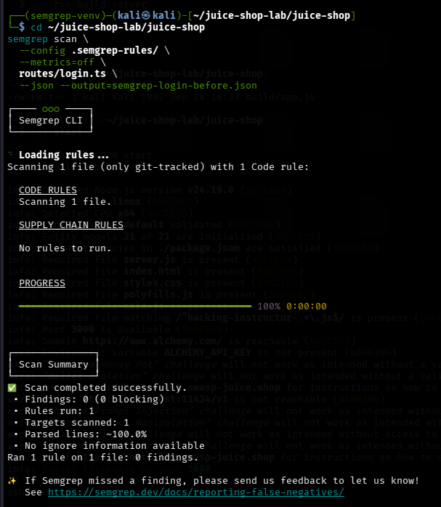
Before / After Summary

Metric | Before Fix | After Fix
Semgrep finding count on login.ts | 1 | 0
Exploit payload ' OR TRUE-- | Admin login succeeds | Login rejected
SQL query construction | String interpolation | Parameterized (? + replacements)
Root cause present | Yes | No
CWE-89 compliant | No | Yes

